**BUSINESS PLAN**

MPU 22012

ENTREPRENEURSHIP

GROUP 1

MRZ_PASTA

DET4C

|  |  |
| --- | --- |
| MUHAMMAD AQIL LUQMAN BIN NOIDAN | 03DET22F1035 |

1.Table of Content ;

* Introduction
* Purpose of preparing Business Plan
* Company's background
* Ownership background
* Project background
* Management/Organization Plan
* Marketing Plan
* Operation Plan
* Financial Plan
* Project Schedule
* Conclusion
* Appendix

Introduction

Since a few weeks ago, we have noticed that pasta and soda have become a trend among the youth. Seizing this opportunity, we have launched MRZ PASTA, a premium pasta and soda brand that offers exclusive delivery services and caters to special events such as project presentations. Our new product line, which was launched two weeks ago, aims to capitalize on the current trend and the unique taste of our products. Key PointsTrending Products: MRZ PASTA offers a range of pasta and soda products that are currently popular among the youth.

* Exclusive Delivery: We provide exclusive delivery services to ensure our customers receive their orders promptly and efficiently.
* Special Events: Our brand caters to special events, such as project presentations, to provide a unique and memorable experience for our customers.
* Premium Quality: MRZ PASTA prides itself on offering high-quality products that are both delicious and satisfying.
* Affordable Prices: Despite our premium quality, we offer our products at affordable prices to make them accessible to a wider audience.

Purpose of Preparing Business Plan

The creation of a business plan serves many different purposes and is essential to the success of any enterprise. A business plan is a road map that describes the objectives, approaches, and actions required to reach them. It serves as a dynamic road map for managing and growing a company, keeping things focused, getting outside funding, igniting goals, charting expansion, and educating top staff. A business plan assists entrepreneurs in staying focused, making educated decisions, identifying potential flaws, communicating ideas with stakeholders, attracting investors, and guaranteeing the sustainability and success of the venture by providing product details, financial estimations, and future plans.

Company’s Background

MRZ Pasta was founded on February 27, 2024, by AQIL, CHEN, and AFIQAH. The company's mission is to provide quality food for everyone and make people happy by enjoying our food. The vision is to sustain the business and create opportunities for people who are jobless. The founding team has a strong commitment to quality and innovation, aiming to make a positive impact on the food industry.

MRZ Pasta is dedicated to providing a unique and enjoyable experience for its customers while capitalizing on the current trend in the market. The company's committed to quality and affordability sets it apart from competitors and ensures that it remains a top choice for pasta and soda lovers.

BACKGROUND OF PARTNER

|  |  |  |  |
| --- | --- | --- | --- |
| NAME | MUHAMMAD AQIL LUQMAN BIN NORIDAN | CHONG KHENG CHEN | NURUL AFIQAH BINTI AZHAR |
| ID NUMBER | 041217080429 | 041104020083 | 040319020238 |
| ADDRESS | No.401, Lorong 8/2, Taman Siswa 2, Jitra Kedah | 97, TAMAN BERJASA JALAN SULTAN ABDUL HALIM 05400 ALOR SETAR KEDAH | NO 35, JALAN DATO KERAMAT, TAMAN SRI AMAN, KUBANG PASU, 06000, KEDAH |
| TELEPHONE NUMBER | 0195796244 | 019-4972588 | 01139488474 |
| FORM OF BUSINESS | PARTNERSHIP | PARTNERSHIP | PARTNERSHIP |
| DATE OF BIRTH AND AGE | 17/12/2004  20year old | 4-11-2004  20year old | 19/03/2004  20year old |
| ACADEMICS QUALIFICATION | SPM | SPM | SPM |
| COURSE ATTENDED | ELETRIC ENGINEERING | ELETRIC ENGINEERING | ELETRIC ENGINEERING |
| SKILLS | BARTENDER | MARKETING | CHEF |
| PRESENT OCCUPATION & EXPERIENCE | brewer | promoter | Chef assistant |

LOCATION OF THE BUSINESS

Company Name: MRZ.PASTA

Address: 27,TMAN SRI UTAMA JITRA 06000 KEDAH

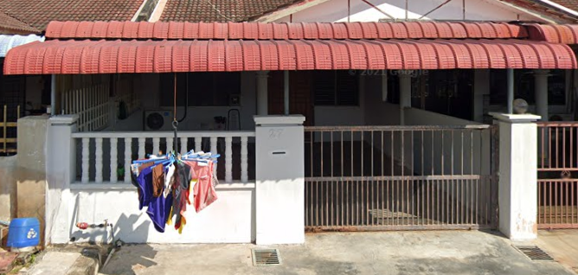Phone: 019-497 2588

Email: mrz.pasta@gmail.com

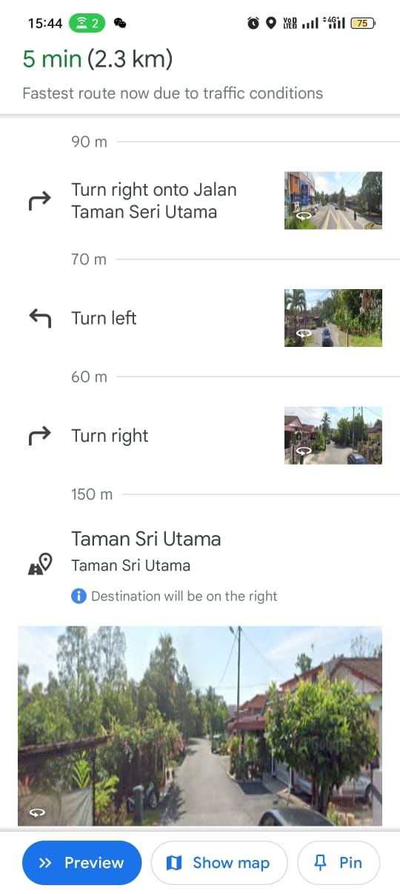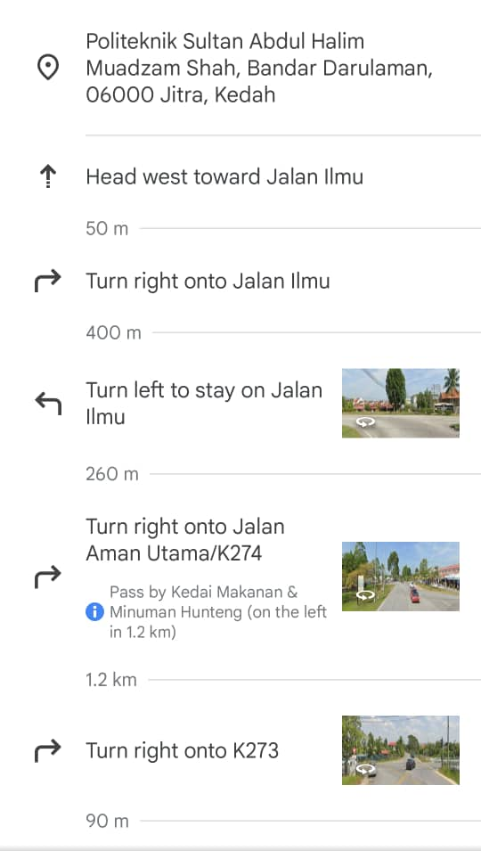

ADMINISTRATION PLAN

**Mission, Vision, and Objectives:**

Mission: Provide high-quality, gourmet food products to delight customers.

Vision: Become a trusted household name known for culinary excellence.

Objectives: Expand product line, increase market share by 15% annually.

**Organizational Chart**

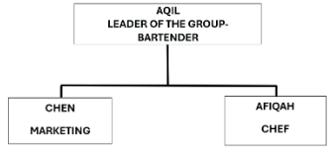

**MANPOWER PLANNING**

Roles and Responsibilities: Define the specific roles needed for the operation of your business. This might include positions such as chefs/cooks, servers, cashiers.

Skill Requirements: Identify the skills and qualifications necessary for each role. For example, chefs should have culinary training or experience, while servers should have good communication and customer service skills.

Scheduling: Develop a staffing schedule that ensures adequate coverage during all operating hours while minimizing labor costs. Consider factors such as employee availability, preferences, and legal requirements regarding breaks and overtime.

Contingency Planning: Have plans in place for handling unexpected staffing shortages, such as illness or sudden increases in demand. This might involve cross-training employees to perform multiple roles or having a pool of on-call staff available as backup.

**SCHEDULE OF TASK AND RESPONSIBILITIES**

Market Research:

Understand who our customers are and what they like.

Check out other pasta and soda sellers to see what they're doing.

Business Planning:

Figure out how much money we need and where to get it.

Make sure we follow all the rules and regulations for selling food.

Supplies and Ingredients:

Find good ingredients for our pasta and soda.

Make sure we always have enough stuff to make our products.

Product Development:

Create tasty pasta dishes and soda flavors.

Ask people to try our food and tell us what they think.

Marketing and Sales:

Tell people about our pasta and soda through ads and promotions.

Make it easy for customers to buy from us, whether online or in person.

Getting Ready to Open:

Find a good location for our business.

Hire and train staff to help run things smoothly.

Promotion:

Offer special deals to attract customers.

Keeping Track and Improving:

Keep an eye on how well we're doing and what customers are saying.

Make changes to our business based on what we learn.

Growing the Business:

Look for ways to expand, like opening more stores or adding new menu items.

Make sure we're doing our part for the environment and our community.

**REMUNERATION PLAN**

Hourly Pay or Salary: Employees get paid for their time worked.

Sales Bonuses: Staff earn extra for selling more.

Profit Sharing: Employees get a cut of the profits as the business succeeds.

Discounts: Staff get discounts on pasta and soda.

**LIST OF OFFICE EQUIPMENT AND SUPPLIES**

Office Equipment:

Computers: Desktops or laptops for administrative tasks, inventory management, and accounting.

Printers/Scanners/Copiers: For printing invoices, scanning documents, and making copies of important paperwork.

Furniture: Desks, chairs, and tables for office workstations .

Stationery: Pens, pencils, notepads, and other writing essentials.

Staplers and Staples: For securing paperwork and documents.

File Folders and Organizers: For keeping paperwork and documents organized.

Labels and Label Maker: For labeling inventory, files, and storage containers.

Calculator: For basic accounting and calculations.

Whiteboard/Flipchart: For brainstorming, planning, and keeping track of tasks.

Cleaning Supplies: To maintain a clean and tidy workspace.

Kitchen Equipment (for pasta and soda preparation):

Refrigeration Units: To store ingredients, sauces, and beverages.

Cooking Equipment: Pots, pans, and utensils for cooking pasta dishes.

Ice Maker: For keeping drinks cold and refreshing.

Food Storage Containers: To store prepared ingredients and leftovers.

Safety Equipment:

Fire Extinguishers: For fire safety.

First Aid Kit: For minor injuries and emergencies.

**ADMINISTRATIVE BUDGET**

Staff Costs: Salaries for administrative employees.

Office Expenses: utilities, and supplies.

Communication: Phone and internet bills.

Technology: Software and hardware costs.

Miscellaneous: Unexpected expenses.

MARKETING PLAN

**Description of products:**

Pasta Types:

We offer classic pasta types like spaghetti and penne, along with specialty options such as gluten-free and organic.

Soda Selection:

Our soda lineup includes popular brands like ICE CREAM SODA, as well as local craft sodas in unique flavours.

Quality and Sourcing:

We prioritize high-quality ingredients sourced from trusted suppliers, ensuring freshness and taste in every bite and sip.

Packaging:

Our products come in convenient, eco-friendly packaging that reflects our commitment to sustainability.

Price and Sizes:

Prices vary based on product and size, with options for individual servings or bulk purchases to accommodate different needs and budgets.

**Target markets and segments:**

Target audience: College students living on or near campus.

Segmentation: Based on dietary preferences, budget constraints and convenience needs.

**Market size:**

There are approximately 8,000 students within a 5-mile radius of campus.

**Competitor analysis:**

Advantages: high brand awareness and convenient location.

Cons: Limited healthy options, higher prices.

**Market share:**

It currently occupies 20% of the student food market.

**Sales Forecast:**

The goal is to capture 30% of the market in the first year and grow revenue by 15% annually thereafter.

**Marketing strategy:**

Social Media Presence: Engage on Instagram, TikTok through menu highlights, recommendations.

Campus Activities: Final Year Project

Loyalty program: Offers discounts for repeat purchases.

Online Ordering: Develop user-friendly website, mobile application for ease of use.

Content Marketing: Provide nutritional tips, lifestyle content to build trust.

**Marketing budget:**

Spread the Word: Budget for ads, flyers, or events to let people know about your products.

Offer Deals: Allocate funds for discounts or promotions to attract customers.

Let Them Try: Set aside money for letting people taste your products.

Share Content: Invest in creating useful content like recipes or tips related to your products.

PRODUCTION PLAN

**Operation Process:**

Source fresh ingredients, prepare meals, package, and deliver to campus locations.

**Production Schedule/Capacity Planning:**

Daily schedule based on demand forecasts and kitchen capacity.

**Material Requirements:**

List of ingredients and packaging materials needed for each menu item.

**Machine and equipment:**

Pasta Making Equipment:

Pasta cooker: For boiling pasta.

Kitchen Equipment:

Oven, stove, and fridge: For cooking and storing ingredients.

Tables, sinks, and dishwasher: For food preparation and cleaning.

Soda Dispensing Equipment:

Soda fountain dispenser: To serve soda.

CO2 tanks and syrup pumps: For carbonation and flavoring.

Packaging and Serving Equipment:

Containers, cups, and lids: For packaging pasta and soda.

Safety and Sanitation Equipment:

Fire extinguisher and first aid kit: For emergencies.

Cleaning supplies: For maintaining cleanliness.

Furniture and Decor:

Tables, chairs, and decor: For customer seating and ambiance.

**Location of operation:**

Busy Spot: Find a place where lots of people are around, like downtown.

Pasta Fans: Look for areas where people like pasta and soda, like downtown where workers and tourists often look for quick meals.

Check the Competition: See if there are already a few pasta places around. If not, it could be a good spot.

Near Other Fun Stuff: Pick a place near other popular spots like stores or parks.

**Operation layout plan:**

Sourcing Ingredients:

Buy pasta and soda supplies from wholesalers.

Food Preparation:

Set up kitchen stations for pasta making and soda preparation.

Keep track of ingredient levels and reorder when necessary.

Menu Development:

Create a menu with popular pasta dishes and soda flavors.

Customer Service:

Train staff to take orders and handle payments efficiently.

Use a simple POS system for order processing.

Packaging and Presentation:

Use eco-friendly containers for takeout orders and branded cups for sodas.

Marketing and Promotion:

Use social media to showcase menu items and offer discounts.

**Operational Cost and Cost Per Unit:**

Operational Costs:

Rent, utilities, ingredients, labor, and other expenses: RM 200per month

Units Produced:

Pasta: 50 servings per month

Soda: 30 bottles per month

Cost Per Unit:

Pasta: RM 7 per serving

Soda: RM 5.5 per bottle

**Operational Budget:**

Revenue Projection:

Estimate monthly sales income.

Cost of Goods Sold (COGS):

Calculate the cost of ingredients for pasta and soda, plus packaging.

Operating Expenses:

Include rent, utilities, insurance, licenses, marketing, equipment upkeep, and transportation.

Miscellaneous Expenses:

Set aside funds for unexpected costs and professional services.

Net Income (or Loss):

Calculate net income by subtracting total expenses from total revenue

FINANCIAL **PLAN**

Source of finance schedule;

-each of company’s partners shared RM60 and the total equal to RM180.

-total ingredients(for a month) :

|  |  |
| --- | --- |
| **Ingredients** | **RM** |
| Onion | 5 |
| Sausage | 6 |
| Marjerin | 3.80x3pack = 11.4 |
| Fresh chicken | 16 |
| Tepung bestari | 10.50 |
| Carbonara sauce | 4x10tin(265g) = 40 |
| Cube pati ayam | 4 |
| Black pepper | 5 |
| Salt | 1.80 |
| Pasta | 3x6 = 18 |
| Oil | 2x3 = 6 |
| Ice cream soda | 2.40x5 = 12 |
| Lemon | 3x3 = 9 |
| Pewarna biru | 11 |

Total = 5+6+11.40+16+10.50+40+4+5+1.80+18+6+12+9+11

= RM155.70

Finance sources – total ingredients = RM180-RM155.70 = RM24.30

Ala carte pasta carbonara = RM7

Ala carte Sky Blue Soda = RM5.50

COMBO = RM11.50

|  |  |
| --- | --- |
| Ala Carte | In a month: |
| Pasta carbonara | 45 set x RM7 = RM315 |
| Sky Blue Soda | 25 cup x RM5.50 = RM137.5 |
| Combo | 5 set x RM11.50 = RM 57.5 |

|  |  |
| --- | --- |
| MRZ PASTA  Income Statement  For month Ended March 31, 2024 | |
| Revenues: | RM |
| Consulting revenue | 509.50 |
| Expenses: |  |
| Salaries expense | (240) |
| Net income | **269.50** |

|  |
| --- |
| 45 set x RM7 = RM315 |
| 25 cup x RM5.50 = RM137.5 |
| 5 set x RM11.50 = RM 57.5 |

Investment by owner + net income = RM180+RM269.50 = RM449.50

|  |  |
| --- | --- |
| MRZ PASTA  Statement of Owner’s Equity  For month Ended March 31, 2024 | |
| Capital, March 31,2024 | RM |
| Plus: Investments by Owner | 180 |
| Net Income | 269.50 |
|  | **449.50** |

|  |  |  |  |  |  |  |  |
| --- | --- | --- | --- | --- | --- | --- | --- |
| **Everyday/activity** | **Sunday** | **Monday** | **Tuesday** | **Wednesday** | **Thursday** | **Friday** |  |
| looking for food & beverage suppliers |  |  |  |  |  |  |  |
| Open online order for the next day |  |  |  |  |  |  |  |
| Cooking n packing process (at noon) |  |  |  |  |  |  |  |
| Start delivery to every buyers  (on 5pm) |  |  |  |  |  |  |  |
| Off day |  |  |  |  |  |  |  |

PROJECT SCHEDULE

CONCLUSION

In conclusion, we hope that our business can be developed as best as possible in accordance with our journey in building a broad idea about the production of this business. Therefore, we also intend to share the pleasure & deliciousness of our products to customers. Finally, with this business plan, we hope that the sales journey of our products can be sold in a more manageable way from beginning to end.